Machine description
Target IP | 192.168.0.109
Vulnerability name | Samba 2.2.8a — Remote Code Execution
Service / version | TCP 139 / SAMBA SMBD
Severity | CRITICAL
CVSS Score | 9.8
Attack vector | CVSS:3.1/AV:N/AC:L/PR:N/UI:N/S:U/C:H/I:H/A:H
Poc | STEP 1 – [ HOST DISCOVERY USING NMAP ]  STEP2 – [ SERVICE VERSION DETECTION SCAN USIN NMAP]  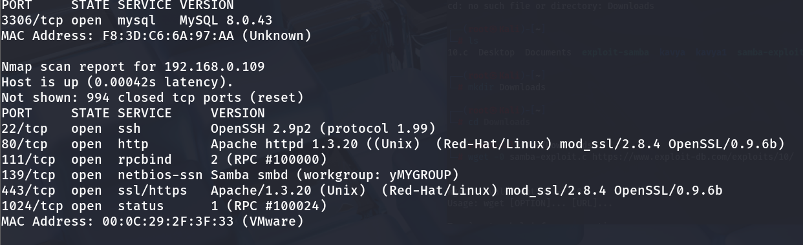  STEP 3 – TO FIND THE HOST NAME  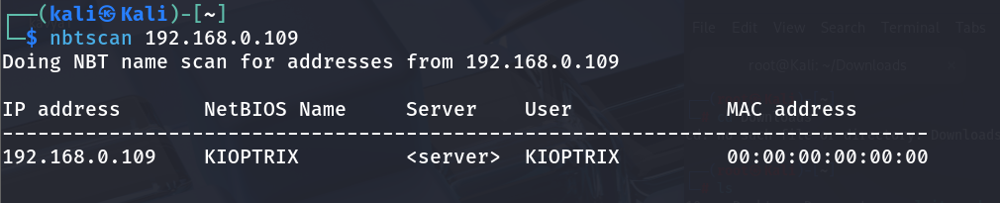  STEP 4- TO ENUMERATE USERS, GROUPS, SHARES, POLICIES, SID ON SAMBA SYSTEM  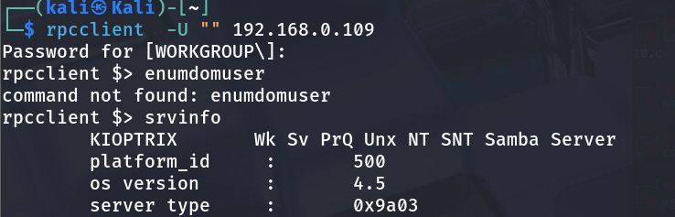  STEP 5- WE FOUND THE TARGET IS RUNNING OUTDATED VERSION OF SAMBA SO WE FOUND EXPLOIT ON EXPLOIT DB  DOWNLOAD THE EXPLOIT CODE  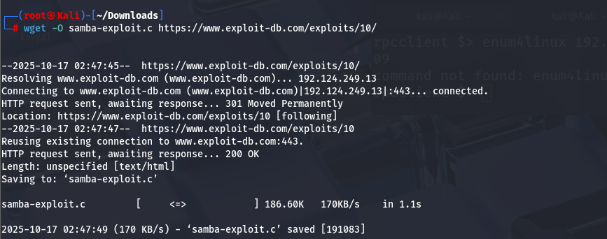  STEP 6 – COMPILE AND RUN THE EXPLOIT  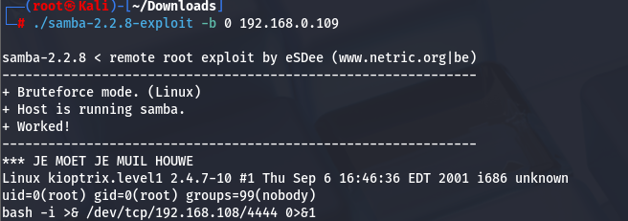  STEP 7- WE GOT ROOT ACESS ON TARGET MACHINE SO WE ARE SPWANING REVERSE BASH SHELL ON OUR NETCAT  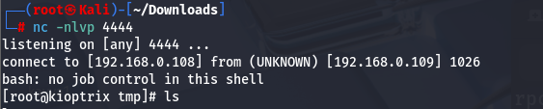  AT THE END WE GOT THE ROOT ACESS AND SPWANED SHELL
IMPACT | - Full remote root access achieved on the target system.  - Complete compromise of confidentiality, integrity, and availability.  - Ability to exfiltrate sensitive data and manipulate system files.  - Potential for pivoting into internal network for further attacks.
REMEDIATIONS | Upgrade Samba to the latest stable, patched version from official repositories.  Apply security patches released by the Samba project to fix known vulnerabilities.  Restrict access to Samba services using firewalls or network segmentation.  Disable anonymous or unnecessary shares and enforce strong authentication
REFERENCE | https://www.exploit-db.com/exploits/10

